Notes: Visitor Design Pattern

1. The Core Problem: The Need for the Visitor Pattern
- The Scenario: Imagine a class A with a few methods (M1, M2). As new requirements come in, more methods (M3, M4, etc.) are added to the same class.
- The Consequences: This approach leads to several design flaws:
  - Violates Open/Closed Principle (OCP): The class is constantly being modified to add new functionality, instead of being extended.
  - Violates Single Responsibility Principle (SRP): The class becomes responsible for too many different operations.
  - Increased Complexity: The class becomes bloated and difficult to test.
- The Core Principle: The fundamental rule of design patterns is to "Extract what changes." In this case, the set of operations is what's changing frequently.

2. A Concrete Example: Document Handling System
- System Structure: We have a DocumentElement parent class with child classes like TextFile, Image, and Video.
- The Problem in Context:
  - A requirement comes to calculate size. A calculateSize() method is added to DocumentElement and implemented in all child classes.
  - A new requirement to compress comes. A compress() method is added to DocumentElement and implemented in all child classes.
  - Another requirement to scan for viruses comes. The same process is repeated.
- The Result: Every time a new operation is needed, the entire DocumentElement hierarchy (TextFile, Image, Video, etc.) must be modified. This is the exact problem the Visitor pattern solves.
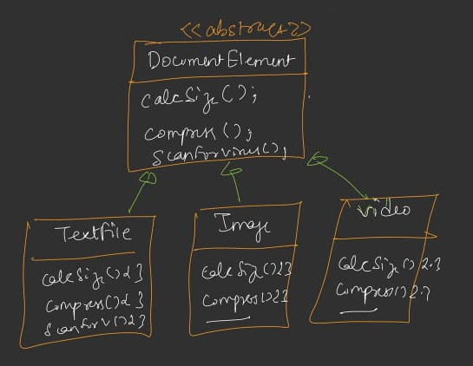

3. How the Visitor Pattern Works
The pattern extracts operations from the object hierarchy and places them into a separate "Visitor" hierarchy.
- Assumption: The types of elements (TextFile, Image, Video) are stable and will not change frequently. The operations performed on them, however, will change.
- Step 1: The Visitor Hierarchy (The Operations)
  - Create an IVisitor interface. This interface has a visit() method overloaded for every type of element in the object hierarchy.
    - visit(TextFile t)
    - visit(Image i)
    - visit(Video v)
  - Create a concrete visitor for each operation:
    - SizeCalculatorVisitor: Implements all three visit methods, with logic for calculating the size of a TextFile, an Image, and a Video.
    - CompressVisitor: Implements all three visit methods with logic for compressing each file type.
    - VirusScannerVisitor: Implements all three visit methods with logic for scanning each file type.
- Step 2: The Element Hierarchy (The Objects)
  - The DocumentElement parent class now has only one abstract method: accept(IVisitor v). This method must be implemented by all child classes.
  - Each child class (TextFile, Image, Video) implements accept() with the exact same logic:
java
// Inside TextFile, Image, or Video class
public void accept(IVisitor v) {
v.visit(this); // 'this' refers to the specific element (e.g., TextFile)
}
  - This part of the code is stable and will almost never change. It simply tells the visitor, "Visit me, and here is who I am."
- Step 3: The Client (Using the System)
  - The client creates an element object (e.g., TextFile file1 = new TextFile();).
  - To perform an operation, the client calls the accept() method on the element and passes an instance of the desired visitor.
java
// To calculate size:
file1.accept(new SizeCalculatorVisitor());

// To compress:
file1.accept(new CompressVisitor());

// To scan for viruses:
file1.accept(new VirusScannerVisitor());
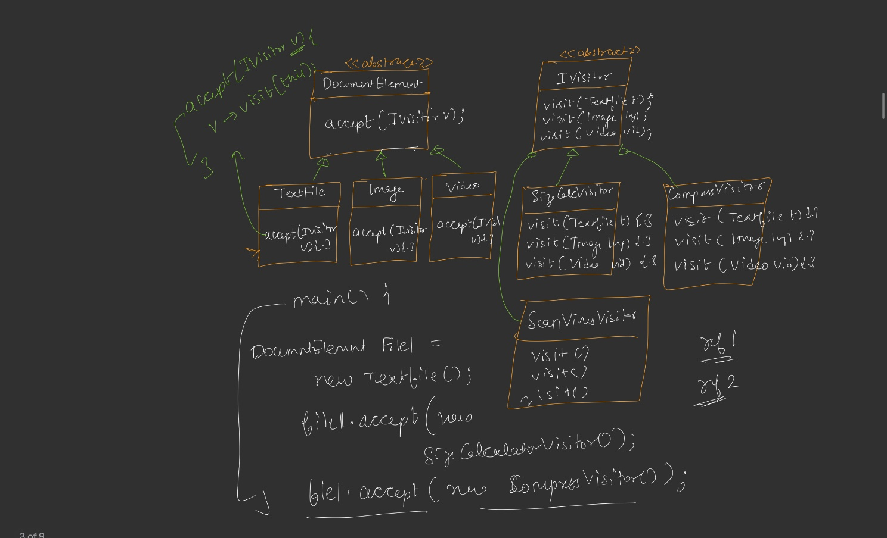

4. The Key Concept: Double Dispatch
- Definition: Double Dispatch is a mechanism where the method that gets executed depends on both the runtime type of the Visitor and the runtime type of the Element.
- How it Works:
  - First Dispatch: The client calls file1.accept(new CompressVisitor()). The dynamic type of file1 (e.g., TextFile) is determined, and the accept() method in the TextFile class is invoked.
  - Second Dispatch: The accept() method then calls v.visit(this). Here, the dynamic type of the visitor (v, which is CompressVisitor) is determined, and the visit(TextFile t) method within the CompressVisitor class is invoked.
- In Simple Terms: Two references (the element and the visitor) work together to determine which specific method is called.
Code…see Notes
Standard UML
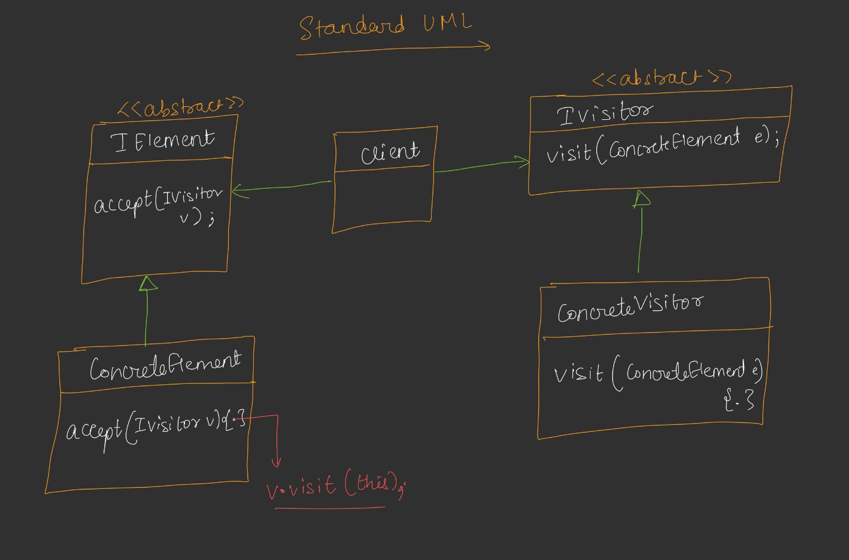

5. Visitor vs. Strategy Pattern
This is a common and important comparison.
Feature | Strategy Pattern | Visitor Pattern
Problem Focus | The number of behaviors of a class is stable, but the ways of performing those behaviors can change. | The number of operations to be performed on an object can change frequently.
What Varies | The algorithm/implementation of a specific behavior (e.g., the many ways to fly). | The operations themselves (e.g., adding calculateSize, compress, scan).
Example | A Robot has a fly behavior. The strategy allows you to switch between FlyWithWings, FlyWithJet, etc., without changing the Robot class. | A DocumentElement has many operations (calculateSize, compress, etc.). New operations can be added by creating new visitors without changing the DocumentElement class.
Analogy | You have a set of tools (strategies) to accomplish the same task (a behavior). | You are adding new tools (visitors) to work on a set of objects (elements).
- Key Takeaway: The Strategy pattern handles changing algorithms. The Visitor pattern handles adding new operations. Using a Strategy for the Visitor's problem would still lead to violating the Open/Closed Principle, as you would need to modify the Robot class to add a new strategy for a new operation (e.g., swim).

6. Standard UML Structure
- Element Hierarchy: IElement interface with accept(IVisitor v). ConcreteElement classes implement this.
- Visitor Hierarchy: IVisitor interface with a visit(ConcreteElement e) method for each concrete element. ConcreteVisitor classes implement these methods.
- Client: A client has references to both an IElement object and an IVisitor object. It calls element.accept(visitor) to initiate the double dispatch.

7. Real-World Use Cases
- Game Rendering Engines: To perform different operations like render, mapHitbox, calculateLighting on a stable set of game objects (e.g., Player, Enemy, Building) without modifying the object classes for each new operation.
- Compilers (Abstract Syntax Trees - ASTs): To traverse the AST and perform operations like type checking, code optimization, or code generation. Each node in the tree is an element, and each operation is a visitor.

8. Standard Definition
The Visitor Design Pattern allows new operations to be added to existing classes without changing their structure. It does this by separating the operation from the object it operates on.

